CLUSTER FRONTLINE DEMONSTRATION OF SUMMER PULSES (2019-20) PERFORMANCE DATA REPORTING FORMAT KVK WISE
- Name of KVK: Jajpur 2. Year of establishment:2002
- Host Institution: OUAT 4. Address: Krishi Vigyan Kendra, Jajpur, Barchana
5. District: Jajpur 6. State: Odisha
7. Performance of the demonstration:
- Technical Parameters:
Sl.  No. | Crop demonstrated | Existing (Farmer's) variety name | Existing yield  (q/ha) | Yield gap (Kg/ha)  w.r.to |  |  | Name of Variety + Technology  demonstrated | Number of farmers | Area in ha | Yield obtained (q/ha) |  |  | Yield gap minimized  (%)
 |  |  |  | District  yield (D) | State  yield (S) | Potential  yield (P)
 |  |  |  |  |  |  |  |  |  | Max. | Min. | Av. | D | S | P
1. | Greengram | Local Variety  (Jhainmuga) | 6.1 | 315 | 434 | 1000 | Improved management practices of Greengram seeds var.IPM-02-14 ,seed treatment with vitavax power and seed inoculation with bio-fertilizer (Rhizobium and PSB) along with soil test based fertilizer + need based plant protection. Chemical (profenofos @2ml/lit & Thiomethoxam 5gm/15 lit of water. | 70 | 30 | 8.5 | 6.8 | 7.9 | 150.79 | 82.02 | 26.58

- Economic parameters
Sl.  No. | Variety demonstrated & Technology demonstrated | Farmer’s Existing plot |  |  |  | Demonstration plot
 |  | Gross Cost  (Rs/ha) | Gross return  (Rs/ha) | Net Return  (Rs/ha) | B:C  ratio | Gross Cost  (Rs/ha) | Gross return  (Rs/ha) | Net Return  (Rs/ha) | B:C  ratio
1 | Improved management practices of Greengram seeds var.IPM-02-14 ,seed treatment with vitavax power and seed inoculation with bio-fertilizer (Rhizobium and PSB) along with soil test based fertilizer + need based plant protection. Chemical (profenofos @2ml/lit & Thiomethoxam 5gm/15 lit of water. | 19500 | 36600 | 17100 | 1.87 | 21500 | 47400 | 25900 | 2.20

- Socio-economic impact parameters
Sl.  No. | Crop and variety  Demonstrated | Total Produce  Obtained (kg) | Produce sold  (Kg/household) | Selling  Rate  (Rs/Kg) | Produce used for own sowing (Kg) | Produce distributed to other farmers (Kg) | Purpose for which income gained was utilized | Employment Generated (Mandays/house hold)
1 | Greengram  Var. IPM-02-14 | 55480 | 600 | 6000 | 500 | 300 | For day to day need | 5

- Farmers’ perception of the intervention demonstrated
Sl.  No. | Technologies demonstrated  (with name) | Farmers' Perception parameters
 |  | Suitability to their farming system | Likings  (Preference) | Affordability | Any negative effect | Is Technology acceptable to all in the group/village | Suggestions, for change/improvement, if any
1 | Improved management practices of Greengram seeds var.IPM-02-14 ,seed treatment with vitavax power and seed inoculation with bio-fertilizer (Rhizobium and PSB) along with soil test based fertilizer + need based plant protection. Chemical (profenofos @2ml/lit & Thiomethoxam 5gm/15 lit of water. | Yes | Yes | Yes | Less market demand by trader | Yes | Establishment of processing unit for value addition and awareness about line sowing of seeds

- Specific Characteristics of Technology and Performance

Specific Characteristic | Performance | Performance of Technology vis-a vis Local Check | Farmers Feedback
Greengram var. IPM-02-14, 70-75 days duration, INM & IPM | Improved management practices of greengram with var. IPM-02-14 enhance the yield 7.9 qtl/ha during rabi | Improved management practices of greengram with var. IPM-02-14 enhance the yield 29.50% over farmers practice. | Farmers are satisfied with variety & the technology

- Extension activities under FLD conducted till dates:

Sl. No. | Extension Activities organized | Date and place of activity | Number of farmer attended
1 | Field visit, Group discussion and Meeting | 20.01.2020 (Badasuar , Bidyadhrapur) | 50
2 | Field visit and Group discussion | 10.02.2020 (Badabarisahi) | 30
3. | Field visit & Group discussion | 13.03.2020 ( Badabarisahi) | 35

8. Sequential good quality photographs (as per crop stages i.e. growth & development)

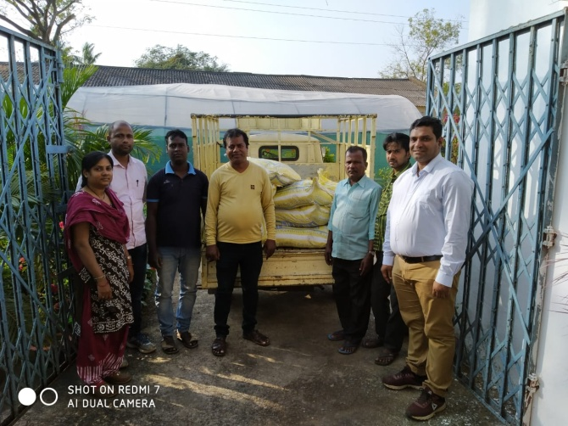 | 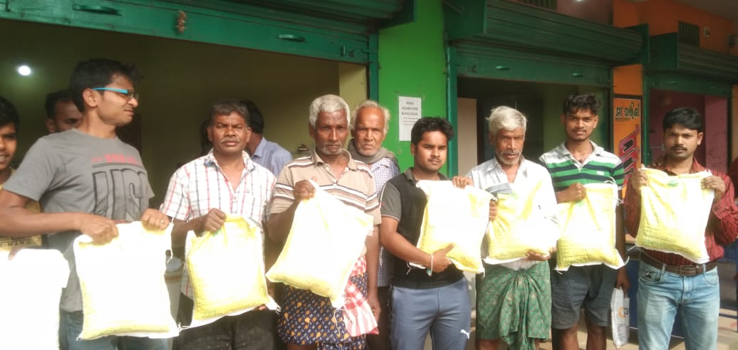 | 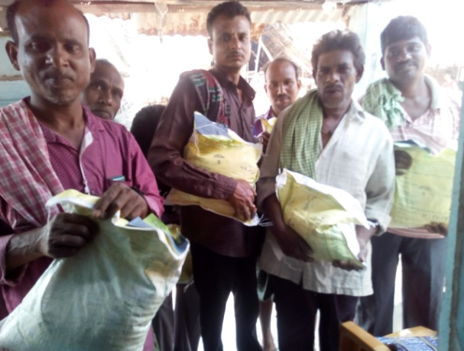
Greengram (var. IPM-02-14) seeds distribution to farmers
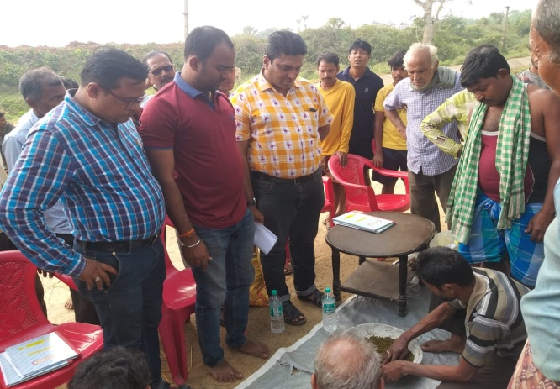 | 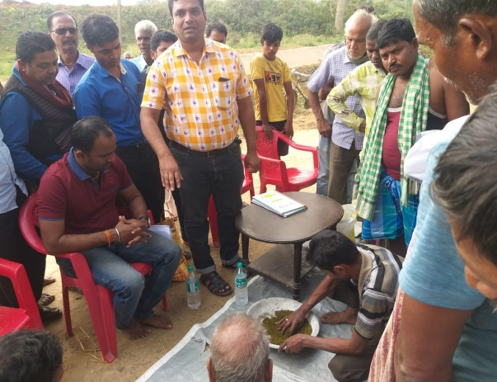 | 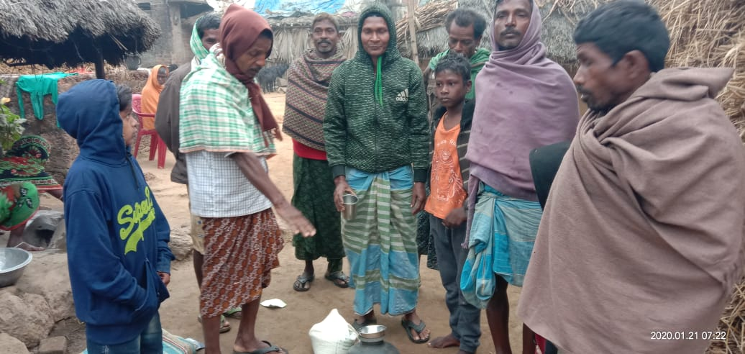
seed treatment with vitavax power & seed inoculation with bio-fertilizer ( Rhizobiumculture &PSB)

9. Farmers' training photographs

10. Quality Photographs of field visits/field days and technology demonstrated.

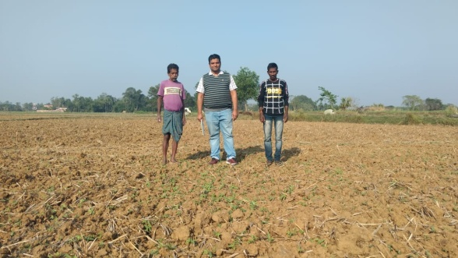 | 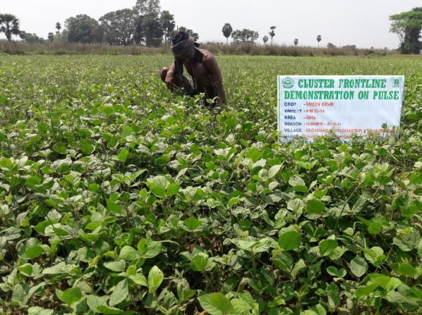 | 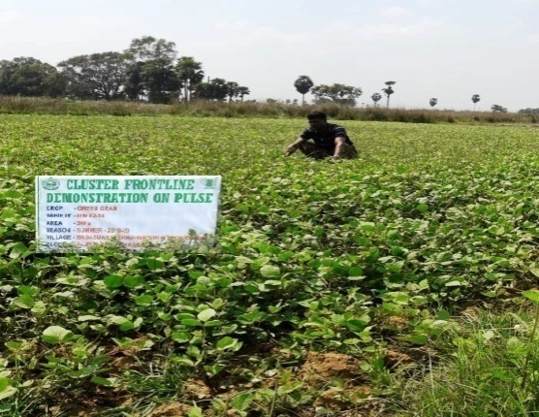
Scientist visited to farmers field | Farmers in the demonstrated field
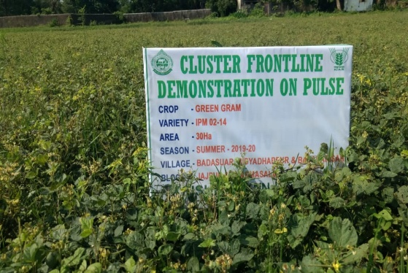 | 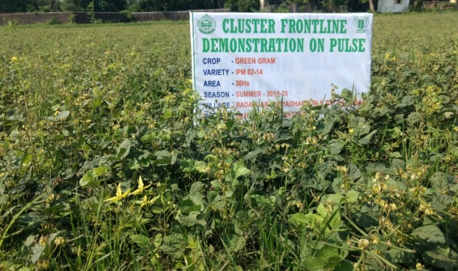 | 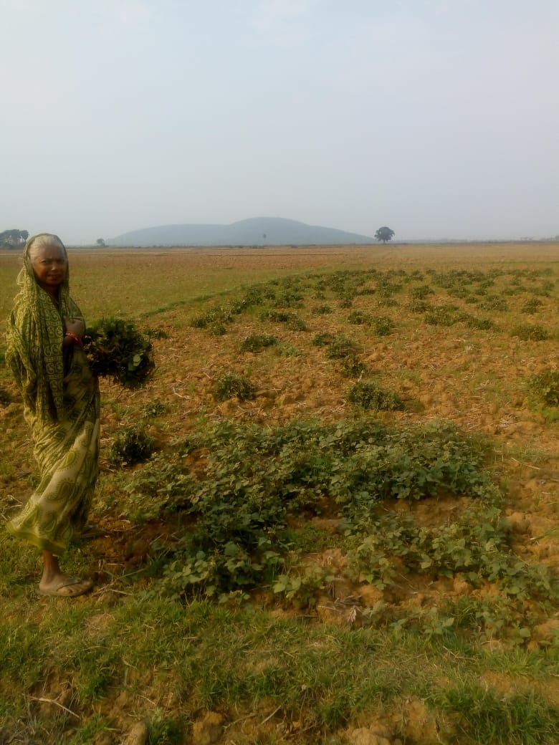
Flowering and pod bearing stage |  | Harvesting crop

11. Details of budget utilization

Crop  (provide crop wise information ) | Items | Budget  Received  (Rs.) | Budget  Utilization  (Rs.) | Balance  (Rs.)
Greengram  (var. IPM-02-14) | i) Critical input | 2,70,000/- | 1,12,514/- | 1,57,486/-
 | ii) TA/DA/POL etc. for monitoring
 | iii) Extension Activities (Field day)
 | iv)Publication of literature
 | Total | 2,70,000/- | 1,12,514/- | 1,57,486/-

12. List of Farmer under FLD (Crop wise)

- Crop1

Name of farmer | Father’s name | Village | Block | Mobile No. | Email ID | GPS Coordinates (DDMMSS format) |  | Soil testing done (Yes/No) | Recommendations based on soil test value | Brief technology intervention | Variety | Area (ha) | Seed quantity used | Demo. Yield (q/ha) |  |  | Yield of local check q/ha | % increase
 |  |  |  |  |  | Latitude | Longitude |  |  |  |  |  |  | H | L | A
Basanta Kumar Parida | Kanhei Parida | Badasuar | Jajpur | 9439897915 |  | 20°46´28.89´´ | 86°20´6.37´´ | Yes | 20:40:20 | Improved management practices of Greengram seeds var.IPM-02-14 ,seed treatment with vitavax power and seed inoculation with bio-fertilizer (Rhizobium and PSB) along with soil test based fertilizer + need based plant protection. Chemical (profenofos @2ml/lit & Thiomethoxam 5gm/15 lit of water. | IPM-02-14 | 0.4 | 8 kg |  |  | 8.2 | 6.1 | 34.42
Bishnu charan Nayak | Kanduri Nayak | Badasuar | Jajpur | 8908954720 |  | 20°46´28.89´´ | 86°20´6.37´´ | Yes | 20:40:20 |  | IPM-02-14 | 0.4 | 8 kg |  |  | 8.0 | 6.1 | 31.14
Keshab Parida | Artabandhu Parida | Badasuar | Jajpur | 8328929242 |  | 20°46´28.89´´ | 86°20´6.37´´ | Yes | 20:40:20 |  | IPM-02-14 | 0.4 | 8 kg |  |  | 7.9 | 6.1 | 29.50
Brundaban Swain | Banthanidhi Swain | Badasuar | Jajpur | 9348712115 |  | 20°46´28.89´´ | 86°20´6.37´´ | Yes | 20:40:20 |  | IPM-02-14 | 0.4 | 8 kg |  |  | 8.3 | 6.1 | 36
Dhirendra kumar Parida | Sankarsana Parida | Badasuar | Jajpur | 7008724064 |  | 20°46´28.89´´ | 86°20´6.37´´ | Yes | 20:40:20 |  | IPM-02-14 | 0.4 | 8 kg |  |  | 8.4 | 6.1 | 37.70
Pramod kumar Nayak | Gourangacharana Nayak | Badasuar | Jajpur | 9776886484 |  | 20°46´28.87´´ | 86°20´6.7´´ | Yes | 20:40:20 |  | IPM-02-14 | 0.4 | 8 kg |  |  | 7.8 | 6.1 | 27.8
Rabinarayan Swain | Bidyadhara Swain | Badasuar | Jajpur | 6370002064 |  | 20°46´28.87´´ | 86°20´6.7´´ | Yes | 20:40:20 |  | IPM-02-14 | 0.4 | 8 kg |  |  | 8.2 | 6.1 | 34.42
Satyananda Matia | Ramachandra Matia | Badasuar | Jajpur | 9439563908 |  | 20°46´28.87´´ | 86°20´6.7´´ | Yes | 20:40:20 |  | IPM-02-14 | 0.4 | 8 kg |  |  | 8.0 | 6.1 | 31.14
Mrutunjaya Biswal | Bhagaban Biswal | Badasuar | Jajpur | 9938539172 |  | 20°46´28.87´´ | 86°20´6.7´´ | Yes | 20:40:20 |  | IPM-02-14 | 0.4 | 8 kg |  |  | 7.7 | 6.1 | 26.22
Uttam Nayak | Surendra Nayak | Badasuar | Jajpur | 8144059108 |  | 20°46´28.87´´ | 86°20´6.7´´ | Yes | 20:40:20 |  | IPM-02-14 | 0.4 | 8 kg |  |  | 8.3 | 6.1 | 36
Chintamani Panda | Artabandhu Panda | Badasuar | Jajpur | 7992703747 |  | 20°46´28.87´´ | 86°20´6.7´´ | Yes | 20:40:20 |  | IPM-02-14 | 0.4 | 8 kg |  |  | 7.7 | 6.1 | 26.22
Purnanda Jena | Panchnan Jena | Badasuar | Jajpur | 9583433980 |  | 20°46´28.85´´ | 86°20´7.2´´ | Yes | 20:40:20 |  | IPM-02-14 | 0.4 | 8 kg |  |  | 8.4 | 6.1 | 37.70
Manoj Parida | Mahendra Parida | Badasuar | Jajpur | 9658203031 |  | 20°46´28.85´´ | 86°20´7.2´´ | Yes | 20:40:20 |  | IPM-02-14 | 0.4 | 8 kg |  |  | 7.9 | 6.1 | 29.50
Chintamani Parida | Rangadhara Parida | Badasuar | Jajpur | 7873695520 |  | 20°46´28.85´´ | 86°20´7.2´´ | Yes | 20:40:20 |  | IPM-02-14 | 0.4 | 8 kg |  |  | 8.0 | 6.1 | 31.14
Nakula Chandra Parida | Artabandhu Parida | Badasuar | Jajpur | 8328929224 |  | 20°46´28.85´´ | 86°20´7.2´´ | Yes | 20:40:20 |  | IPM-02-14 | 0.4 | 8 kg |  |  | 7.8 | 6.1 | 27.8
Paramananda Parida | Bhagaban Parida | Badasuar | Jajpur | 7381917427 |  | 20°46´28.85´´ | 86°20´7.2´´ | Yes | 20:40:20 |  | IPM-02-14 | 0.4 | 8 kg |  |  | 6.8 | 6.1 | 11.47
Shusasan Parida | Baudhara Parida | Badasuar | Jajpur | 7381917427 |  | 20°46´29.69´´ | 86°20´7.88´´ | Yes | 20:40:20 |  | IPM-02-14 | 0.4 | 8 kg |  |  | 8.3 | 6.1 | 36
Pritikanta Parida | Kapil Ch. Parida | Badasuar | Jajpur | 7894173264 |  | 20°46´29.69´´ | 86°20´7.88´´ | Yes | 20:40:20 |  | IPM-02-14 | 0.4 | 8 kg |  |  | 7.7 | 6.1 | 26.22
Pratap chandra Parida | Jaladhara Parida | Badasuar | Jajpur | 9853761485 |  | 20°46´29.69´´ | 86°20´7.88´´ | Yes | 20:40:20 |  | IPM-02-14 | 0.4 | 8 kg |  |  | 8.2 | 6.1 | 34.42
Malaya Parida | Gajendra Parida | Badasuar | Jajpur | 9583628062 |  | 20°46´29.69´´ | 86°20´7.88´´ | Yes | 20:40:20 |  | IPM-02-14 | 0.4 | 8 kg |  |  | 7.8 | 6.1 | 27.8
Bibratan Parida | Ramachandra Parida | Badasuar | Jajpur |  |  | 20°46´29.69´´ | 86°20´7.88´´ | Yes | 20:40:20 |  | IPM-02-14 | 0.4 | 8 kg |  |  | 8.4 | 6.1 | 37.70
Gajendra Parida | Sudhir Parida | Badasuar | Jajpur | 7735772215 |  | 20°46´29.69´´ | 86°20´7.88´´ | Yes | 20:40:20 |  | IPM-02-14 | 0.4 | 8 kg |  |  | 8.2 | 6.1 | 34.42
Rajesh Parida | Sarat Ch. Parida | Badasuar | Jajpur | 7978565074 |  | 20°46´29.69´´ | 86°20´7.88´´ | Yes | 20:40:20 |  | IPM-02-14 | 0.4 | 8 kg |  |  | 7.8 | 6.1 | 27.8
Arun kumar Swain | Dhoi Ch. Swain | Badasuar | Jajpur | 8338061137 |  | 20°46´29.69´´ | 86°20´7.88´´ | Yes | 20:40:20 |  | IPM-02-14 | 0.4 | 8 kg |  |  | 8.4 | 6.1 | 37.70
Bibhutibhusan Parida | Parameswar Parida | Badasuar | Jajpur | 8328113091 |  | 20°46´29.69´´ | 86°20´7.88´´ | Yes | 20:40:20 |  | IPM-02-14 | 0.4 | 8 kg |  |  | 7.7 | 6.1 | 26.22
Manoj kumar Nayak | Gayadhara Nayak | Bidyadharapur | Jajpur |  |  | 20°91´23.08´´ | 86°37´81.21´´ | Yes | 20:40:20 |  | IPM-02-14 | 0.4 | 8 kg |  |  | 7.8 | 6.1 | 27.8
Deepak Nath | Sidheswar Nath | Bidyadharapur | Jajpur | 8249475592 |  | 20°92´03.43´´ | 86°37´36.28´´ | Yes | 20:40:20 |  | IPM-02-14 | 0.4 | 8 kg |  |  | 7.9 | 6.1 | 29.50
Sarat Nath | Indumani Nath | Bidyadharapur | Jajpur | 9776036446 |  | 20°91´25.92´´ | 86°37´68.51´´ | Yes | 20:40:20 |  | IPM-02-14 | 0.4 | 8 kg |  |  | 8.3 | 6.1 | 36
Laxmidhar Rana | Vikari Rana | Bidyadharapur | Jajpur | 9040519783 |  | 20°91´25.92´´ | 86°37´68.51´´ | Yes | 20:40:20 |  | IPM-02-14 | 0.4 | 8 kg |  |  | 7.8 | 6.1 | 27.8
Umarani Nayak | Chndrasekhar Nayak | Bidyadharapur | Jajpur | 9078096452 |  | 20°91´06.34´´ | 86°36´82.80´´ | Yes | 20:40:20 |  | IPM-02-14 | 0.4 | 8 kg |  |  | 8.0 | 6.1 | 31.14
Indu Maharana | Iswar Maharana | Bidyadharapur | Jajpur | 9938351194 |  | 20°91´06.34´´ | 86°36´82.80´´ | Yes | 20:40:20 |  | IPM-02-14 | 0.4 | 8 kg |  |  | 8.2 | 6.1 | 34.42
Jhuna Nath | Bijaya Nath | Bidyadharapur | Jajpur | 8596815425 |  | 20°91´06.34´´ | 86°36´82.80´´ | Yes | 20:40:20 |  | IPM-02-14 | 0.4 | 8 kg |  |  | 7.9 | 6.1 | 29.50
Jasoda Nath | Susnata Nath | Bidyadharapur | Jajpur | 8114965270 |  | 20°91´06.34´´ | 86°36´82.80´´ | Yes | 20:40:20 |  | IPM-02-14 | 0.4 | 8 kg |  |  | 8.3 | 6.1 | 36
Urmila Rana | Surendra Rana | Bidyadharapur | Jajpur | 9776075196 |  | 20°91´82.24´´ | 86°37´90.10´´ | Yes | 20:40:20 |  | IPM-02-14 | 0.4 | 8 kg |  |  | 8.0 | 6.1 | 31.14
Hari Mallick | Basudev Mallick | Bidyadharapur | Jajpur | 9833161622 |  | 20°91´82.24´´ | 86°37´90.10´´ | Yes | 20:40:20 |  | IPM-02-14 | 0.4 | 8 kg |  |  | 7.8 | 6.1 | 27.8
Sibaprasad Rout | Gayadhara Rout | Bidyadharapur | Jajpur | 9937712925 |  | 20°91´82.24´´ | 86°37´90.10´´ | Yes | 20:40:20 |  | IPM-02-14 | 0.4 | 8 kg |  |  | 7.9 | 6.1 | 29.50
Sanatan Rana | Gopal Rana | Bidyadharapur | Jajpur |  |  | 20°94´20.89´´ | 86°36´82.92´´ | Yes | 20:40:20 |  | IPM-02-14 | 0.4 | 8 kg |  |  | 8.0 | 6.1 | 31.14
Bhagabat Sethi | Ganagadhara Sethi | Bidyadharapur | Jajpur | 7873081301 |  | 20°94´20.89´´ | 86°36´82.92´´ | Yes | 20:40:20 |  | IPM-02-14 | 0.4 | 8 kg |  |  | 8.2 | 6.1 | 34.42
Bhagabat Nath | Badyanath Nath | Bidyadharapur | Jajpur | 9337051347 |  | 20°94´20.89´´ | 86°36´82.92´´ | Yes | 20:40:20 |  | IPM-02-14 | 0.4 | 8 kg |  |  | 8.4 | 6.1 | 37.70
Kartika Nath | Basudev Nath | Bidyadharapur | Jajpur | 7897926832 |  | 20°94´20.89´´ | 86°36´82.92´´ | Yes | 20:40:20 |  | IPM-02-14 | 0.4 | 8 kg |  |  | 7.2 | 6.1 | 18.03
Makar ketan Nath | Basudev Nath | Bidyadharapur | Jajpur | 9831393443 |  | 20°94´21.12´´ | 86°36´82.80´´ | Yes | 20:40:20 |  | IPM-02-14 | 0.4 | 8 kg |  |  | 8.3 | 6.1 | 36
Pradip chandra Singh | Ramachnadra Singh | Bidyadharapur | Jajpur | 9348277496 |  | 20°94´21.10´´ | 86°36´80.79´´ | Yes | 20:40:20 |  | IPM-02-14 | 0.4 | 8 kg |  |  | 7.9 | 6.1 | 29.50
Pramila Rout | Nabaghana Rout | Bidyadharapur | Jajpur | 7064209875 |  | 20°94´21.10´´ | 86°36´80.79´´ | Yes | 20:40:20 |  | IPM-02-14 | 0.4 | 8 kg |  |  | 8.2 | 6.1 | 34.42
Papunee Nath | Chandan Ku. Nath | Bidyadharapur | Jajpur | 7681097768 |  | 20°91´82.24´´ | 86°37´90.10´´ | Yes | 20:40:20 |  | IPM-02-14 | 0.4 | 8 kg |  |  | 7.2 | 6.1 | 18.03
Bharati Nath | Jadumani Nath | Bidyadharapur | Jajpur | 7381751581 |  | 20°91´82.24´´ | 86°37´90.10´´ | Yes | 20:40:20 |  | IPM-02-14 | 0.4 | 8 kg |  |  | 8.0 | 6.1 | 31.14
Uma Rout | Ananda Rout | Bidyadharapur | Jajpur |  |  | 20°91´24.74´´ | 86°37´76.26´´ | Yes | 20:40:20 |  | IPM-02-14 | 0.4 | 8 kg |  |  | 7.0 | 6.1 | 14.75
Amulya Rout | Arjun Rout | Bidyadharapur | Jajpur | 7682805899 |  | 20°91´24.74´´ | 86°37´76.26´´ | Yes | 20:40:20 |  | IPM-02-14 | 0.4 | 8 kg |  |  | 8.4 | 6.1 | 37.70
Manoj kumar Nath | Bidyadahara Nath | Bidyadharapur | Jajpur | 9777237800 |  | 20°94´21.06´´ | 86°36´82.85´´ | Yes | 20:40:20 |  | IPM-02-14 | 0.4 | 8 kg |  |  | 7.0 | 6.1 | 14.75
Bijay Nath | Sanatana Nath | Bidyadharapur | Jajpur | 8596815425 |  | 20°94´21.06´´ | 86°36´82.85´´ | Yes | 20:40:20 |  | IPM-02-14 | 0.4 | 8 kg |  |  | 8.0 | 6.1 | 31.14
Narendra Rout | Bira Rout | Bidyadharapur | Jajpur | 6370211871 |  | 20°94´21.06´´ | 86°36´82.85´´ | Yes | 20:40:20 |  | IPM-02-14 | 0.4 | 8 kg |  |  | 8.2 | 6.1 | 34.42
Srikanta Mallik | Padana Mallik | Badabarisahi | Dharmasala | 7656825550 |  | 20°43´20.85´´ | 86°10´57.92´´ | Yes | 20:40:20 |  | IPM-02-14 | 0.6 | 12 kg |  |  | 7.8 | 6.1 | 27.8
Aruna Mallik | Sanatana Mallik | Badabarisahi | Dharmasala | 8895473303 |  | 20°43´21.61´´ | 86°10´59.89´´ | Yes | 20:40:20 |  | IPM-02-14 | 0.6 | 12 kg |  |  | 7.0 | 6.1 | 14.75
Upendra Mallik | Pok Mallik | Badabarisahi | Dharmasala | 9434883917 |  | 20°43´20.39´´ | 86°10´59.28´´ | Yes | 20:40:20 |  | IPM-02-14 | 0.6 | 12 kg |  |  | 7.2 | 6.1 | 18.03
Bijay Mallik | Kanhu Mallik | Badabarisahi | Dharmasala | 7735919404 |  | 20°43´21.48´´ | 86°10´1.16´´ | Yes | 20:40:20 |  | IPM-02-14 | 0.6 | 12 kg |  |  | 8.3 | 6.1 | 36
Bilash Mallik | Hari Mallik | Badabarisahi | Dharmasala |  |  | 20°43´27.50´´ | 86°10´51.78´´ | Yes | 20:40:20 |  | IPM-02-14 | 0.4 | 8 kg |  |  | 8.0 | 6.1 | 31.14
Manoranjan Mallik | Akshya Mallik | Badabarisahi | Dharmasala |  |  | 20°43´27.50´´ | 86°10´51.78´´ | Yes | 20:40:20 |  | IPM-02-14 | 0.4 | 8 kg |  |  | 7.7 | 6.1 | 26.22
Karunakar Mallik | Charana Mallik | Badabarisahi | Dharmasala | 8895473303 |  | 20°43´20.56´´ | 86°10´58.93´´ | Yes | 20:40:20 |  | IPM-02-14 | 0.4 | 8 kg |  |  | 8.3 | 6.1 | 36
Ashok Mallik | Balakrushna Mallik | Badabarisahi | Dharmasala | 8018943542 |  | 20°43´26.90´´ | 86°10´51.24´´ | Yes | 20:40:20 |  | IPM-02-14 | 0.6 | 12 kg |  |  | 7.0 | 6.1 | 14.75
Sagar Mallik | Ghanashyama Mallik | Badabarisahi | Dharmasala |  |  | 20°43´27.37´´ | 86°10´50.65´´ | Yes | 20:40:20 |  | IPM-02-14 | 0.4 | 8 kg |  |  | 8.2 | 6.1 | 34.42
Jhari Mallik | Barini Mallik | Badabarisahi | Dharmasala |  |  | 20°43´27.37´´ | 86°10´50.65´´ | Yes | 20:40:20 |  | IPM-02-14 | 0.4 | 8 kg |  |  | 8.3 | 6.1 | 36
Natabara Mallik | Barini Mallik | Badabarisahi | Dharmasala |  |  | 20°43´27.37´´ | 86°10´50.65´´ | Yes | 20:40:20 |  | IPM-02-14 | 0.4 | 8 kg |  |  | 7.9 | 6.1 | 29.50
Ajay kumar Mallik | Nilamani Mallik | Badabarisahi | Dharmasala | 8280590883 |  | 20°43´27.50´´ | 86°10´51.78´´ | Yes | 20:40:20 |  | IPM-02-14 | 0.6 | 12 kg |  |  | 8.5 | 6.1 | 39.34
Balaram Mallik | Jaladhara Mallik | Badabarisahi | Dharmasala | 8280890883 |  | 20°43´27.50´´ | 86°10´51.78´´ | Yes | 20:40:20 |  | IPM-02-14 | 0.4 | 8 kg |  |  | 7.8 | 6.1 | 27.8
Meghanada Mallik | Jitendra Mallik | Badabarisahi | Dharmasala | 8280890883 |  | 20°43´27.50´´ | 86°10´51.78´´ | Yes | 20:40:20 |  | IPM-02-14 | 0.6 | 12 kg |  |  | 7.2 | 6.1 | 18.03
Manasa Mallik | Sita Mallik | Badabarisahi | Dharmasala |  |  | 20°43´27.50´´ | 86°10´51.78´´ | Yes | 20:40:20 |  | IPM-02-14 | 0.4 | 8 kg |  |  | 8.0 | 6.1 | 31.14
Chitaranjan Mallik | Purusottama Mallik | Badabarisahi | Dharmasala |  |  | 20°43´26.11´´ | 86°10´51.78´´ | Yes | 20:40:20 |  | IPM-02-14 | 0.4 | 8 kg |  |  | 7.7 | 6.1 | 26.22
Nidhi Mallik | Bishi Mallik | Badabarisahi | Dharmasala | 8980519626 |  | 20°43´25.91´´ | 86°10´51.74´´ | Yes | 20:40:20 |  | IPM-02-14 | 0.4 | 8 kg |  |  | 7.8 | 6.1 | 27.8
Monorama Mallik | Jayaram Mallik | Badabarisahi | Dharmasala |  |  | 20°43´25.91´´ | 86°10´51.74´´ | Yes | 20:40:20 |  | IPM-02-14 | 0.6 | 12 kg |  |  | 8.2 | 6.1 | 34.42
Sulochana Mallik | Mathuli Mallik | Badabarisahi | Dharmasala | 8895559998 |  | 20°43´25.91´´ | 86°10´51.74´´ | Yes | 20:40:20 |  | IPM-02-14 | 0.6 | 12 kg |  |  | 7.9 | 6.1 | 29.50
Narendra Mallik | Upendra Mallik | Badabarisahi | Dharmasala | 9348839717 |  | 20°43´20.39´´ | 86°10´59.28´´ | Yes | 20:40:20 |  | IPM-02-14 | 0.6 | 12 kg |  |  | 8.3 | 6.1 | 36

- Crop2

Name of farmer | Father’s name | Village | Block | Mobile No. | Email ID | GPS Coordinates (DDMMSS format) |  | Soil testing done (Yes/No) | Recommendations based on soil test value | Area (ha) | Brief technology intervention | Variety | Seed quantity used | Demo. Yield (q/ha) |  |  | Yield of local check q/ha | % increase
 |  |  |  |  |  | Latitude | Longitude |  |  |  |  |  |  | H | L | A

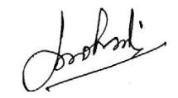

___________________________ _______________________
Signature of Head of Organization Signature of Programme Co-coordinator

