CLUSTER FRONTLINE DEMONSTRATION OF KHARIF PULSES (2019-20) PERFORMANCE DATA REPORTING FORMAT KVK WISE
- Name of KVK: Jajpur 2. Year of establishment:2002
- Host Institution: OUAT 4. Address: Krishi Vigyan Kendra, Jajpur, Barchana
5. District: Jajpur 6. State: Odisha
7. Performance of the demonstration:
- Technical Parameters:
Sl.  No. | Crop demonstrated | Existing (Farmer's) variety name | Existing yield  (q/ha) | Yield gap (Kg/ha)  w.r.to |  |  | Name of Variety + Technology  demonstrated | Number of farmers | Area in ha | Yield obtained (q/ha) |  |  | Yield gap minimized  (%)
 |  |  |  | District  yield (D) | State  yield (S) | Potential  yield (P)
 |  |  |  |  |  |  |  |  |  | Max. | Min. | Av. | D | S | P
1. | Blackgram  Var-PU-31 | Local Variety | 5.1 | 324 | 427 | 1100 | PU-31 +Seed treatment with Vitavax power @2gm/kg of seeds followed by seed inoculation with Rhizobium and PSB, Foliar spray with NPK 19:19:19 & need based plant protection chemicals | 70 | 30 | 7.0 | 5.8 | 6.5 | 100.61 | 52.22 | 69.23

- Economic parameters
Sl.  No. | Variety demonstrated & Technology demonstrated | Farmer’s Existing plot |  |  |  | Demonstration plot
 |  | Gross Cost  (Rs/ha) | Gross return  (Rs/ha) | Net Return  (Rs/ha) | B:C  ratio | Gross Cost  (Rs/ha) | Gross return  (Rs/ha) | Net Return  (Rs/ha) | B:C  ratio
1 | PU-31 +Seed treatment with Vitavax power @2gm/kg of seeds followed by seed inoculation with Rhizobium and PSB, Foliar spray with NPK 19:19:19 & need based plant protection chemicals | 21,300 | 30,600 | 9,300 | 1.43 | 22,500 | 39,000 | 16,500 | 1.73

- Socio-economic impact parameters
Sl.  No. | Crop and variety  Demonstrated | Total Produce  Obtained (kg) | Produce sold  (Kg/household) | Selling  Rate  (Rs/Kg) | Produce used for own sowing (Kg) | Produce distributed to other farmers (Kg) | Purpose for which income gained was utilized | Employment Generated (Mandays/house hold)
1 | PU-31 +Seed treatment with Vitavax power @2gm/kg of seeds followed by seed inoculation with Rhizobium and PSB, Foliar spray with NPK 19:19:19 & need based plant protection chemicals | 45620 | 400 | 55 | 300 | 100 | For day today need | 4

- Farmers’ perception of the intervention demonstrated
Sl.  No. | Technologies demonstrated  (with name) | Farmers' Perception parameters
 |  | Suitability to their farming system | Likings  (Preference) | Affordability | Any negative effect | Is Technology acceptable to all in the group/village | Suggestions, for change/improvement, if any
1 | PU-31 +Seed treatment with Vitavax power @2gm/kg of seeds followed by seed inoculation with Rhizobium and PSB, Foliar spray with NPK 19:19:19 & need based plant protection chemicals | Yes | Yes | Yes | Less market demand by trader | Yes | Establishment of processing unit for value addition and awareness about line sowing of seeds

- Specific Characteristics of Technology and Performance

Specific Characteristic | Performance | Performance of Technology vis-a vis Local Check | Farmers Feedback
Blackgram var. PU-31 | 6.5 | 27.45 | Farmers are satisfied with variety & the technology

- Extension activities under FLD conducted till dates:

Sl. No. | Extension Activities organized | Date and place of activity | Number of farmer attended
1 | Group Discussion | 29.08.2019, Vill- Kaibalyagadia | 35
2 | Group discussion & distribution of critical inputs | 21.09.2019,  Vill-Kaibalyagadia & Gadamadhupur | 70
3. | Field visit & group discussion | 18.10.2019,  Vill-Kaibalyagadia & Gadamadhupur | 25
4 | Field visit & Group discussion | 8.11.2019,  Vill-Gadamadhupur & Kaibalyagaida | 30
5. | Field Day | 23.12.2019  Vill- Gadamadhupur | 50

8. Sequential good quality photographs (as per crop stages i.e. growth & development)

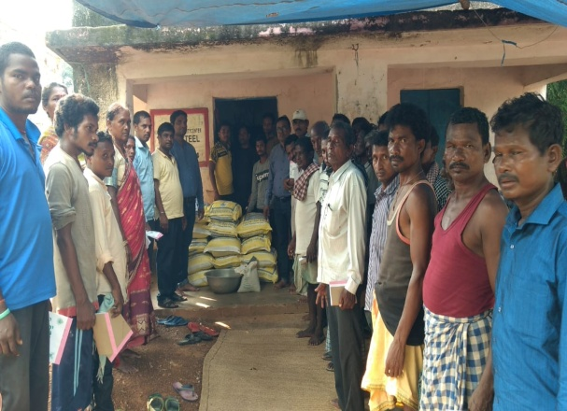 | 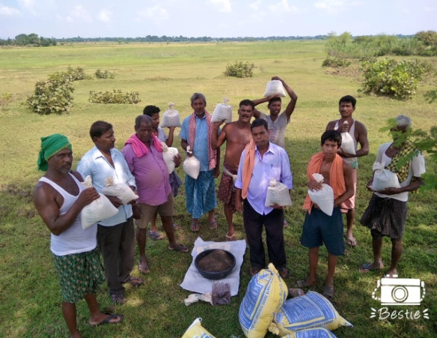 | 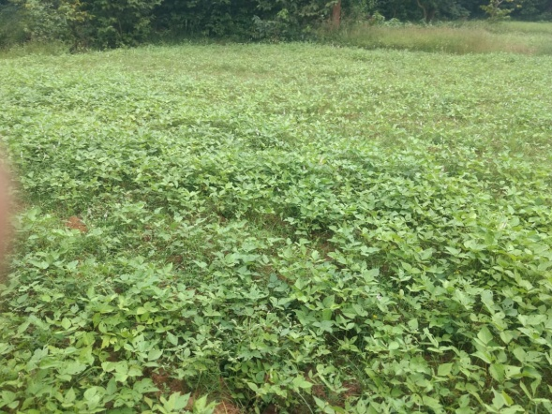
Distribution of critical inputs |  | Vegetative stage
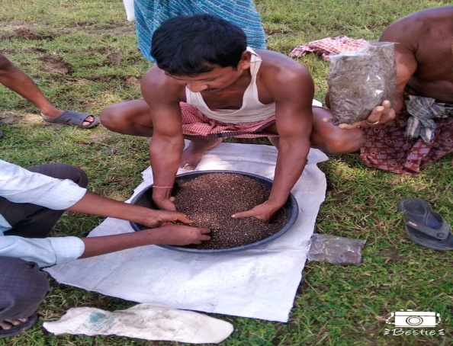 | 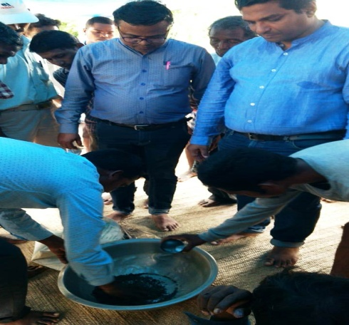 | 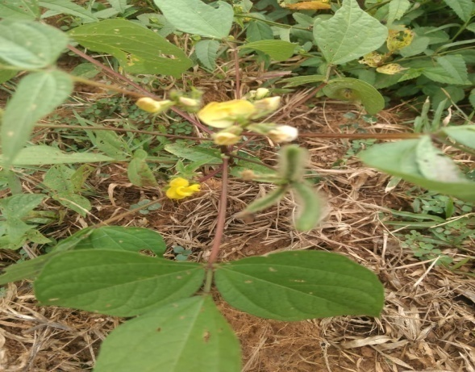
Seed inoculation with Rhizobium and PSB |  | Flowering and pod bearing stage

9. Farmers' training photographs

10. Quality Photographs of field visits/field days and technology demonstrated.

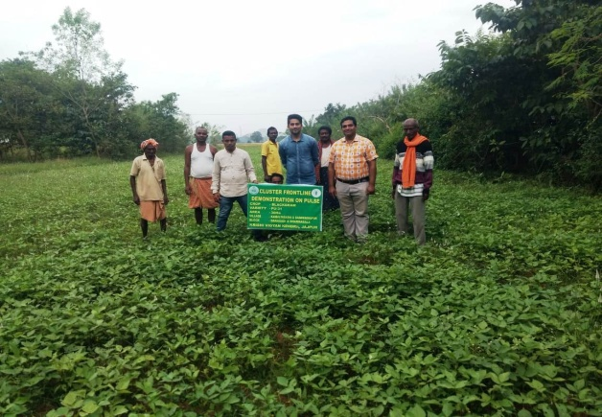 | 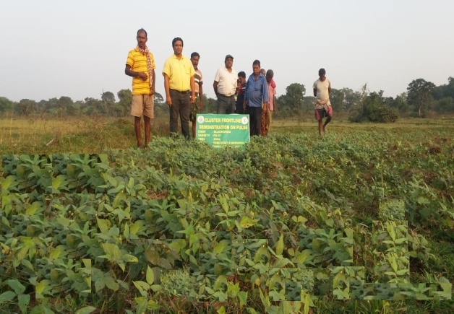 | 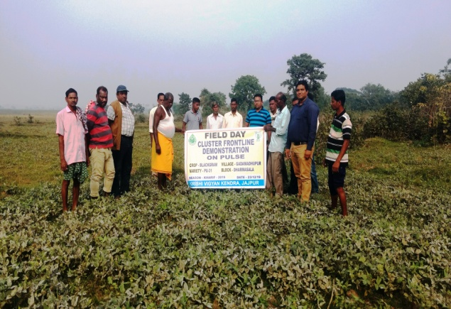
Scientists visit to farmer’s field |  | Field Day
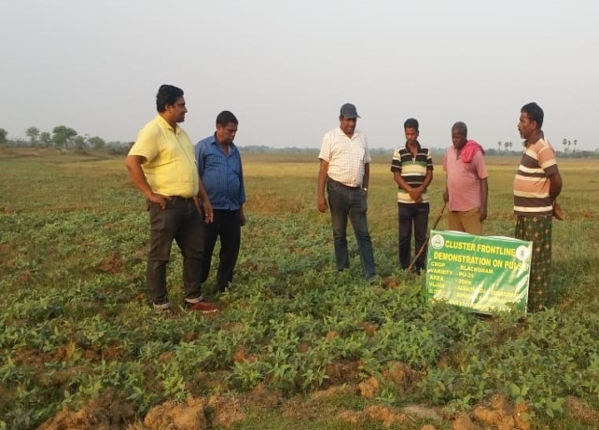 | 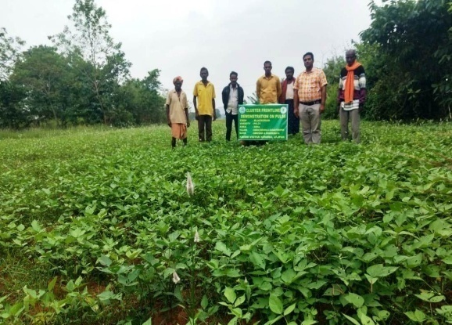 | 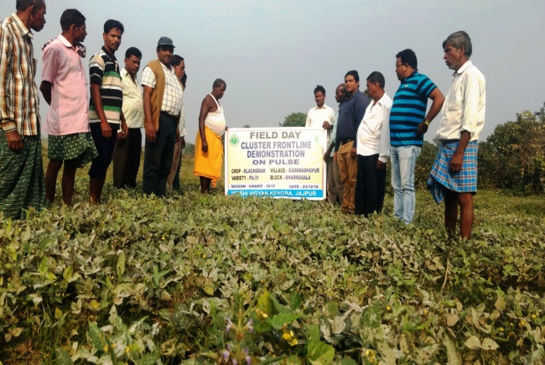

11. Details of budget utilization

Crop  (provide crop wise information ) | Items | Budget  Received  (Rs.) | Budget  Utilization  (Rs.) | Balance  (Rs.)
 | i) Critical input | 2,68,800/- | 1,56,513/- | 1,12,287/-
 | ii) TA/DA/POL etc. for monitoring
 | iii) Extension Activities (Field day)
 | iv)Publication of literature
 | Total | 2,68,800/- | 1,56,513/- | 1,12,287/-

12. List of Farmer under FLD (Crop wise)

- Crop1

Name of farmer | Father’s name | Village | Block | Mobile No. | Email ID | GPS Coordinates (DDMMSS format) |  | Soil testing done (Yes/No) | Recommendations based on soil test value | Brief technology intervention | Variety | Area (ha) | Seed quantity used | Demo. Yield (q/ha) |  |  | Yield of local check q/ha | % increase
 |  |  |  |  |  | Latitude | Longitude |  |  |  |  |  |  | H | L | A
Rama Chandra Dangil | Pradhan Dangil | Kaibalyagadia | Danagadi | 9937940507 |  | 21⁰00’58.4” | 86⁰00’43.8” | Yes | 20:40:20 | PU-31 +Seed treatment with Vitavax power @2gm/kg of seeds followed by seed inoculation with Rhizobium and PSB, Foliar spray with NPK 19:19:19 & need based plant protection chemicals | PU-31 | 1.5 | 12 |  |  | 7.0 | 5.1 | 37.25
Biswamber Bandia | Brundaban Bandia | Kaibalyagadia | Danagadi | - |  | 21⁰00’58.4” | 86⁰00’43.8” | Yes | 20:40:20 |  | PU-31 | 1.5 | 12 |  |  | 6.9 | 5.1 | 35.29
Pradhan Birua | Nageswar Birua | Kaibalyagadia | Danagadi | - |  | 21⁰00’58.4” | 86⁰00’43.8” | Yes | 20:40:20 |  | PU-31 | 1.0 | 8 |  |  | 6.6 | 5.1 | 29.41
Krushna Ch. Mohanta | Khirod Mohanta | Kaibalyagadia | Danagadi | 9178153982 |  | 21⁰00’58.4” | 86⁰00’43.8” | Yes | 20:40:20 |  | PU-31 | 1.5 | 12 |  |  | 6.5 | 5.1 | 27.45
Churni Samad | Raya Samad | Kaibalyagadia | Danagadi | - |  | 21⁰00’58.4” | 86⁰00’43.8” | Yes | 20:40:20 |  | PU-31 | 1.0 | 8 |  |  | 6.9 | 5.1 | 35.29
Bijay Soy | Pradhan Soy | Kaibalyagadia | Danagadi | - |  | 21⁰00’58.4” | 86⁰00’43.8” | Yes | 20:40:20 |  | PU-31 | 1.0 | 8 |  |  | 6.1 | 5.1 | 19.6
Sikandar Munduri | Churni Munduri | Kaibalyagadia | Danagadi | - |  | 21⁰00’58.4” | 86⁰00’43.8” | Yes | 20:40:20 |  | PU-31 | 1.5 | 12 |  |  | 6.7 | 5.1 | 31.57
Malati Munda | Madan Munda | Kaibalyagadia | Danagadi | - |  | 21⁰00’58.4” | 86⁰00’43.8” | Yes | 20:40:20 |  | PU-31 | 1.0 | 8 |  |  | 6.9 | 5.1 | 35.29
Ajit Ku. Mohanta | Banabihari Mohanta | Kaibalyagadia | Danagadi | - |  | 21⁰00’58.4” | 86⁰00’43.8” | Yes | 20:40:20 |  | PU-31 | 1.5 | 12 |  |  | 6.4 | 5.1 | 25.49
Biswajit Purty | Madhu Purty | Kaibalyagadia | Danagadi | - |  | 21⁰01’14.1” | 86⁰00’43.9” | Yes | 20:40:20 |  | PU-31 | 1.0 | 8 |  |  | 6.6 | 5.1 | 29.41
Berga Munduri | Churni Munduri | Kaibalyagadia | Danagadi | - |  | 21⁰01’14.1” | 86⁰00’43.9” | Yes | 20:40:20 |  | PU-31 | 1.0 | 8 |  |  | 6.8 | 5.1 | 33.35
Jayram Samad | Madhu Samad | Kaibalyagadia | Danagadi | - |  | 21⁰01’14.1” | 86⁰00’43.9” | Yes | 20:40:20 |  | PU-31 | 1.0 | 8 |  |  | 6.5 | 5.1 | 27.45
Damodar Munduri | Pradhan Munduri | Kaibalyagadia | Danagadi | - |  | 21⁰01’14.1” | 86⁰00’43.9” | Yes | 20:40:20 |  | PU-31 | 1.5 | 12 |  |  | 6.6 | 5.1 | 29.41
Landu Soy | Dansar Soy | Kaibalyagadia | Danagadi |  |  | 21⁰01’14.1” | 86⁰00’43.9” | Yes | 20:40:20 |  | PU-31 | 1.0 | 8 |  |  | 6.7 | 5.1 | 31.57
Khirod Mohanta | Chandramohan Mohanta | Kaibalyagadia | Danagadi |  |  | 21⁰01’14.1” | 86⁰00’43.9” | Yes | 20:40:20 |  | PU-31 | 1.5 | 12 |  |  | 6.4 | 5.1 | 25.49
Rashika Jena | Babu Jena | Kaibalyagadia | Danagadi |  |  | 21⁰01’14.1” | 86⁰00’43.9” | Yes | 20:40:20 |  | PU-31 | 1.5 | 12 |  |  | 6.6 | 5.1 | 29.41
Lalbahadur Mohanta | Gauranga Mohanta | Kaibalyagadia | Danagadi |  |  | 21⁰01’14.1” | 86⁰00’43.9” | Yes | 20:40:20 |  | PU-31 | 1.5 | 12 |  |  | 6.8 | 5.1 | 33.35
Biswanath Soy | Tripura Soy | Kaibalyagadia | Danagadi |  |  | 21⁰01’14.1” | 86⁰00’43.9” | Yes | 20:40:20 |  | PU-31 | 1.5 | 12 |  |  | 6.5 | 5.1 | 27.45
Jambi Bandia | Hari Bandia | Kaibalyagadia | Danagadi |  |  | 21⁰1’14.1” | 86⁰00’42.7” | Yes | 20:40:20 |  | PU-31 | 1.0 | 8 |  |  | 6.6 | 5.1 | 29.41
Nandini Bandia | Madhusudan Bandia | Kaibalyagadia | Danagadi |  |  | 21⁰1’14.1” | 86⁰00’42.7” | Yes | 20:40:20 |  | PU-31 | 1.0 | 8 |  |  | 6.7 | 5.1 | 31.57
Chakradhara Mohanta | Dinabandhu Mohanta | Kaibalyagadia | Danagadi |  |  | 21⁰1’14.1” | 86⁰00’42.7” | Yes | 20:40:20 |  | PU-31 | 1.0 | 8 |  |  | 6.4 | 5.1 | 25.49
Rakesh Ku. Mohanta | Surat Mohanta | Kaibalyagadia | Danagadi |  |  | 21⁰1’14.1” | 86⁰00’42.7” | Yes | 20:40:20 |  | PU-31 | 1.0 | 8 |  |  | 6.6 | 5.1 | 29.41
Rama Ch. Jena | Tilei Jena | Kaibalyagadia | Danagadi |  |  | 21⁰1’14.1” | 86⁰00’42.7” | Yes | 20:40:20 |  | PU-31 | 1.0 | 8 |  |  | 6.4 | 5.1 | 25.49
Rajkishore Soy | Sava Soy | Kaibalyagadia | Danagadi |  |  | 21⁰1’14.1” | 86⁰00’42.7” | Yes | 20:40:20 |  | PU-31 | 1.0 | 8 |  |  | 6.7 | 5.1 | 31.57
Madhusudan Soy | Sava Soy | Kaibalyagadia | Danagadi |  |  | 21⁰1’14.1” | 86⁰00’42.7” | Yes | 20:40:20 |  | PU-31 | 1.0 | 8 |  |  | 6.5 | 5.1 | 27.45
Bijaya Ojha | Ramachandra Ojha | Kaibalyagadia | Danagadi |  |  | 21⁰1’14.1” | 86⁰00’42.7” | Yes | 20:40:20 |  |  | 1.0 | 8 |  |  | 6.7 | 5.1 | 31.57
Abinash Samad | Sibananda Samad | Kaibalyagadia | Danagadi |  |  | 21⁰1’14.1” | 86⁰00’42.7” | Yes | 20:40:20 |  | PU-31 | 1.0 | 8 |  |  | 6.4 | 5.1 | 25.49
Madhusudan Barda | Basudev Barda | Kaibalyagadia | Danagadi |  |  | 21⁰1’14.1” | 86⁰00’42.7” | Yes | 20:40:20 |  | PU-31 | 1.0 | 8 |  |  | 6.5 | 5.1 | 27.45
Sahadev Sahoo | Purusottam Sahoo | Kaibalyagadia | Danagadi | 7749852782 |  | 21⁰1’14.0” | 86⁰00’41.7” | Yes | 20:40:20 |  | PU-31 | 1.0 | 8 |  |  | 6.3 | 5.1 | 23.52
Ramachanadra Balai | Bagun Balai | Kaibalyagadia | Danagadi | 7894606112 |  | 21⁰1’14.0” | 86⁰00’41.7” | Yes | 20:40:20 |  | PU-31 | 1.0 | 8 |  |  | 6.8 | 5.1 | 33.35
Pradhan Balai | Jagaram Balai | Kaibalyagadia | Danagadi | 9178171790 |  | 21⁰1’14.0” | 86⁰00’41.7” | Yes | 20:40:20 |  | PU-31 | 1.0 | 8 |  |  | 6.4 | 5.1 | 25.49
Rupa Balai | Jayaram Balai | Kaibalyagadia | Danagadi |  |  | 21⁰1’14.0” | 86⁰00’41.7” | Yes | 20:40:20 |  | PU-31 | 1.0 | 8 |  |  | 5.8 | 5.1 | 13.72
Keshab Balai | Jayaram Balai | Kaibalyagadia | Danagadi |  |  | 21⁰1’14.0” | 86⁰00’41.7” | Yes | 20:40:20 |  | PU-31 | 1.0 | 8 |  |  | 6.6 | 5.1 | 29.41
Manika Mohanta | Sanatan Mohanta | Kaibalyagadia | Danagadi |  |  | 21⁰1’14.0” | 86⁰00’41.7” | Yes | 20:40:20 |  | PU-31 | 1.0 | 8 |  |  | 6.2 | 5.1 | 21.56
Sumitra Banara | Churmi Banara | Kaibalyagadia | Danagadi |  |  | 21⁰1’14.0” | 86⁰00’41.7” | Yes | 20:40:20 |  | PU-31 | 1.0 | 8 |  |  | 6.8 | 5.1 | 33.35
Dabara Munda | Dibakar Munda | Kaibalyagadia | Danagadi |  |  | 21⁰1’14.0” | 86⁰00’41.7” | Yes | 20:40:20 |  | PU-31 | 1.0 | 8 |  |  | 6.2 | 5.1 | 21.56
Gangi Munda | Ghanashyam Munda | Kaibalyagadia | Danagadi |  |  | 21⁰1’16.0” | 86⁰00’40.0” | Yes | 20:40:20 |  | PU-31 | 1.0 | 8 |  |  | 6.7 | 5.1 | 31.57
Shyam Munduri | Sadu Munduri | Kaibalyagadia | Danagadi |  |  | 21⁰1’16.0” | 86⁰00’40.0” | Yes | 20:40:20 |  | PU-31 | 1.0 | 8 |  |  | 6.2 | 5.1 | 21.56
Jayanta Mallik | Jaladhar Mallik | Kaibalyagadia | Danagadi |  |  | 21⁰1’16.0” | 86⁰00’40.0” | Yes | 20:40:20 |  | PU-31 | 1.0 | 8 |  |  | 6.5 | 5.1 | 27.45
Hari Bandia | Burunda Bandia | Kaibalyagadia | Danagadi |  |  | 21⁰1’16.0” | 86⁰00’40.0” | Yes | 20:40:20 |  | PU-31 | 1.0 | 8 |  |  | 6.9 | 5.1 | 35.29
Saheb Samad | Madhu Samad | Kaibalyagadia | Danagadi |  |  | 21⁰1’16.0” | 86⁰00’40.0” | Yes | 20:40:20 |  | PU-31 | 1.0 | 8 |  |  | 6.3 | 5.1 | 23.52
Trinath Mohanta | Tanu Mohanta | Kaibalyagadia | Danagadi |  |  | 21⁰1’16.0” | 86⁰00’40.0” | Yes | 20:40:20 |  | PU-31 | 1.0 | 8 |  |  | 6.4 | 5.1 | 25.49
Lalmohan Mohanta | Tanu Mohanta | Kaibalyagadia | Danagadi |  |  | 21⁰1’16.0” | 86⁰00’40.0” | Yes | 20:40:20 |  | PU-31 | 1.0 | 8 |  |  | 6.6 | 5.1 | 29.41
Shyamsundar Purty | Jambira Purty | Kaibalyagadia | Danagadi |  |  | 21⁰1’16.0” | 86⁰00’40.0” | Yes | 20:40:20 |  | PU-31 | 1.0 | 8 |  |  | 6.3 | 5.1 | 23.52
Keshab Birua | Baju Birua | Kaibalyagadia | Danagadi |  |  | 21⁰1’16.0” | 86⁰00’40.0” | Yes | 20:40:20 |  | PU-31 | 1.0 | 8 |  |  | 6.5 | 5.1 | 27.45
Ganesh Behera | Hari Behera | Gadamadhupur | Dharmasala | 8338979577 |  | 20⁰47’50.51” | 86⁰05’11.69” | Yes | 20:40:20 |  | PU-31 | 1.0 | 8 |  |  | 6.7 | 5.1 | 31.57
Biswanath Maharana | Laxman Maharana | Gadamadhupur | Dharmasala |  |  | 20⁰47’50.51” | 86⁰05’11.69” | Yes | 20:40:20 |  | PU-31 | 1.0 | 8 |  |  | 6.1 | 5.1 | 19.60
Giridhari Behera | Chakradhar Behera | Gadamadhupur | Dharmasala |  |  | 20⁰47’50.51” | 86⁰05’11.69” | Yes | 20:40:20 |  | PU-31 | 1.0 | 8 |  |  | 6.5 | 5.1 | 27.45
Narayan Dhir | Kusa Dhir | Gadamadhupur | Dharmasala |  |  | 20⁰47’50.51” | 86⁰05’11.69” | Yes | 20:40:20 |  | PU-31 | 1.0 | 8 |  |  | 6.7 | 5.1 | 31.57
Santosh Behera | Ganesh Behera | Gadamadhupur | Dharmasala |  |  | 20⁰47’43.79” | 86⁰05’11.69” | Yes | 20:40:20 |  | PU-31 | 1.0 | 8 |  |  | 6.3 | 5.1 | 23.52
Nilakantha Behera | Ganeswar Behera | Gadamadhupur | Dharmasala | 8338979577 |  | 20⁰47’43.79” | 86⁰05’11.69” | Yes | 20:40:20 |  | PU-31 | 1.0 | 8 |  |  | 6.9 | 5.1 | 35.29
Kulamani Behera | Nilamani Behera | Gadamadhupur | Dharmasala | 97774349918 |  | 20⁰47’42.56” | 86⁰05’11.55” | Yes | 20:40:20 |  | PU-31 | 1.0 | 8 |  |  | 6.5 | 5.1 | 27.45
Anadi Pradhan | Padua Pradhan | Gadamadhupur | Dharmasala |  |  | 20⁰47’42.56” | 86⁰05’11.55” | Yes | 20:40:20 |  | PU-31 | 1.0 | 8 |  |  | 6.4 | 5.1 | 25.49
Indramani Behera | Alu Behera | Gadamadhupur | Dharmasala | 9937110800 |  | 20⁰47’44.91” | 86⁰05’13.02” | Yes | 20:40:20 |  | PU-31 | 1.0 | 8 |  |  | 6.3 | 5.1 | 23.52
Ghanshyam Dhir | Madanmohan Dhir | Gadamadhupur | Dharmasala | 7327787180 |  | 20⁰47’44.91” | 86⁰05’13.02” | Yes | 20:40:20 |  | PU-31 | 1.0 | 8 |  |  | 6.7 | 5.1 | 31.57
Narayan Behera | Khati Behera | Gadamadhupur | Dharmasala | 9114446022 |  | 20⁰47’44.91” | 86⁰05’13.02” | Yes | 20:40:20 |  | PU-31 | 1.0 | 8 |  |  | 6.3 | 5.1 | 23.52
Mohan Behera | Sendha Behera | Gadamadhupur | Dharmasala |  |  | 20⁰47’44.91” | 86⁰05’13.03” | Yes | 20:40:20 |  | PU-31 | 1.0 | 8 |  |  | 6.5 | 5.1 | 27.45
Shyamsundar Bhanja | Babaji Bhanja | Gadamadhupur | Dharmasala |  |  | 20⁰47’44.91” | 86⁰05’13.03” | Yes | 20:40:20 |  | PU-31 | 1.0 | 8 |  |  | 6.1 | 5.1 | 19.60
Bhajamana Behera | Basu Behera | Gadamadhupur | Dharmasala |  |  | 20⁰47’44.91” | 86⁰05’13.03” | Yes | 20:40:20 |  | PU-31 | 1.0 | 8 |  |  | 6.3 | 5.1 | 23.52
Hemanta Maharana | Biswanath Maharana | Gadamadhupur | Dharmasala |  |  | 20⁰47’44.91” | 86⁰05’13.03” | Yes | 20:40:20 |  | PU-31 | 1.0 | 8 |  |  | 6.8 | 5.1 | 33.35
Pradeep Maharana | Gopinath Maharana | Gadamadhupur | Dharmasala |  |  | 20⁰47’44.81” | 86⁰05’12.16” | Yes | 20:40:20 |  | PU-31 | 1.0 | 8 |  |  | 6.2 | 5.1 | 21.56
Pandab Barik | Raghu Barik | Gadamadhupur | Dharmasala |  |  | 20⁰47’44.81” | 86⁰05’12.16” | Yes | 20:40:20 |  | PU-31 | 1.0 | 8 |  |  | 6.3 | 5.1 | 23.52
Raja Behera | Nilamani Behera | Gadamadhupur | Dharmasala | 8847848386 |  | 20⁰47’50.29” | 86⁰05’11.46” | Yes | 20:40:20 |  | PU-31 | 1.0 | 8 |  |  | 6.6 | 5.1 | 29.41
Shyamsundar Behera | Udhav Behera | Gadamadhupur | Dharmasala |  |  | 20⁰47’49.72” | 86⁰05’11.56” | Yes | 20:40:20 |  | PU-31 | 1.0 | 8 |  |  | 6.4 | 5.1 | 25.49
Biswanath Behera | Jagu Behera | Gadamadhupur | Dharmasala |  |  | 20⁰47’49.17” | 86⁰05’11.40” | Yes | 20:40:20 |  | PU-31 | 1.0 | 8 |  |  | 6.1 | 5.1 | 19.60
Sudam Behera | Babaji Behera | Gadamadhupur | Dharmasala |  |  | 20⁰47’49.17” | 86⁰05’11.40” | Yes |  |  | PU-31 | 1.0 | 8 |  |  | 6.7 | 5.1 | 31.57
Madan Behera | Sendha Behera | Gadamadhupur | Dharmasala |  |  | 20⁰47’49.17” | 86⁰05’11.40” | Yes |  |  | PU-31 | 1.0 | 8 |  |  | 6.1 | 5.1 | 19.60
Prasanna Kumar Mishra | Laxman Mishra | Gadamadhupur | Dharmasala |  |  | 20⁰47’49.72” | 86⁰05’11.56” | Yes |  |  | PU-31 | 1.0 | 8 |  |  | 6.6 | 5.1 | 29.41
Subhendu Kumar Barik | Maheswar Barik | Gadamadhupur | Dharmasala |  |  | 20⁰47’45.00” | 86⁰05’12.62” | Yes |  |  | PU-31 | 1.0 | 8 |  |  | 6.4 | 5.1 | 25.49
Kuna Behera | Khati Behera | Gadamadhupur | Dharmasala |  |  | 20⁰47’45.00” | 86⁰05’12.62” | Yes |  |  | PU-31 | 1.0 | 8 |  |  | 6.2 | 5.1 | 21.56

- Crop2

Name of farmer | Father’s name | Village | Block | Mobile No. | Email ID | GPS Coordinates (DDMMSS format) |  | Soil testing done (Yes/No) | Recommendations based on soil test value | Area (ha) | Brief technology intervention | Variety | Seed quantity used | Demo. Yield (q/ha) |  |  | Yield of local check q/ha | % increase
 |  |  |  |  |  | Latitude | Longitude |  |  |  |  |  |  | H | L | A

___________________________ _______________________
Signature of Head of Organization Signature of Programme Co-coordinator

