Salient achievements of On –Farm Testing (OFT) (Best three):
Crop/  Component | Season | Technology Assessed  (Give in detail) | Farmers’ practice  (Give in detail) | OFT yield  (q/ha) | Yield in farmers’ practice (q/ha) | % increase in yield
Bittergourd | Rabi | Assessment of different trellis in bittergourd for higher production in rabi  TO1- Single trellis, one row trellis constructed with bamboo poles & GI wires, jute rope.  TO2- Lean to type trellis – stakes are joined between two adjoining bed forming an A shaped structure horizontal stakes are installed at the top joining of all other beds . The stakes support the climbing vines. Strings are used to secure adjoining stakes. trellis height 2m | Ground trailing | TO1- 181.7  TO2- 215.3 | 142.1 | TO1- 27.8  TO2- 51.5
Rice | Kharif | IWM in transplanted rice  TO1- Pre émergence application of herbicide (Bensulfuron methyl 0.6%+ Pretilachlor 6.0%) @ 10 kg/ha at 4 DAT + HW at 30 DAT  TO2- Post emergence application of herbicide Penuxulam at 12 DAT + HW at 30 DAT | Manual weeding at 30 DAT | TO1- 46.7  TO2- 52.8 | 39.7 | TO1- 17.6  TO2- 32.9
Groundnut | Rabi, 2019-20 | Assessment of liming for higher productivity in groundnut duringr rabi  TO1- Application of soil test based fertiliser+0.2 LR (PMS) in furrows at the time of sowing  TO2- Application of soil test based fertiliser+0.2 LR (PMS)+FYM 5t/ha in furrows at the time of sowing | No use of lime and application of soil test based fertilizer & FYM in lower dose | TO1- 20.84  TO2- 22.71 | 17.12 | TO1- 21.72  TO2- 32.65

Photographs
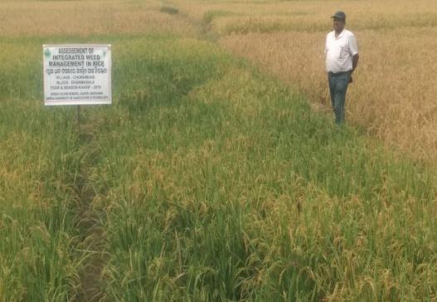  OFT on IWM in transplanted rice | 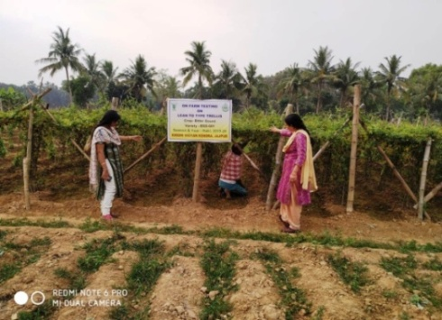  OFT on Lean to type trellis in bittergourd | 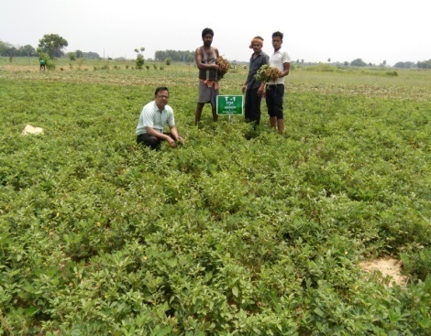  OFT on liming for higher productivity in groundnut

