Salient achievements of frontline demonstration (Best three):
Title | Season | Intervention  (Give in detail) | Farmers’ practice  (Give in detail) | FLD yield  (q/ha) | Yield in farmers’ practice  (q/ha) | % increase in yield
Demonstration on IWM in groundnut under Irrigated medium land situation | Rabi 2019-20 | Use of post emergence herbicide Imazethapyr @750 ml/ha at 20 DAS | Manual weeding at 20 DAS | 24.9 | 20.3 | 22.7
Demonstration on tomato variety ArkaRakshak | Rabi  2019-20 | Cultivation of tomato variety ArkaRakshak with recommended package of practices, planting Oct-Nov, spacing- 2.5 ft X 2.5 ft. , 9900 seedling/ha , fertilizer -150:120:150 kg/ha | Cultivation of tomato variety Priya | 382.4 | 287.7 | 32.9
Demonstration on multicrop seed cum fertilizer drill for sowing groundnut | Rabi  2019-20 | Tractor drawn Multi crop Seed cum fertilizer drill with cup feed metering mechanism for sowing, Field capacity – 0.4ha/h | Sowing of groundnut seed behind the plough | 21.9 | 19.5 | 12.35

Photographs

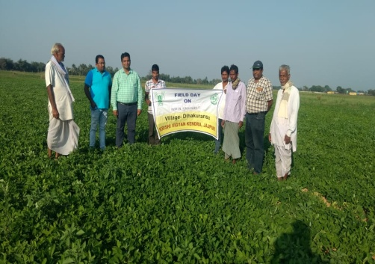  FLD on IWM in groundnut | 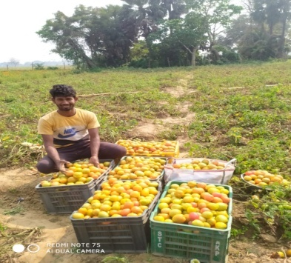  FLD on tomato var.ArkaRakshyak | 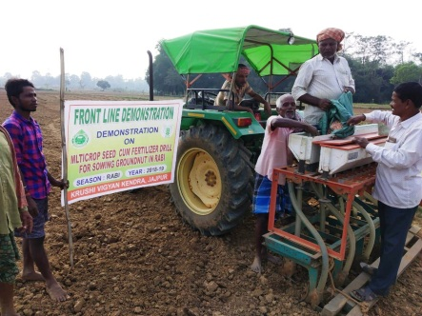  FLD on multicrop seed cum fertilizer drill for sowing groundnut

